Smart Campus Energy Monitoring and Energy Optimization
Assignment Report

Problem Statement
Most colleges don't really track how much power each building on campus is using. Lights and fans in empty classrooms, lab equipment left switched on after hours, AC running in the hostel when nobody's around — this adds up over a semester and nobody notices until the electricity bill comes. Checking every building by hand isn't realistic either, especially on a campus with five or six separate blocks.
The idea behind this project is a small monitoring system that watches each building's power usage hour by hour, flags anything that looks off (like a reading way above what that building normally uses), and prints out simple suggestions on what to fix. Since I don't have access to actual smart meters installed in the buildings, the readings are generated by a simulation instead — it mimics how a real building would behave (low load at night, higher load during the day, occasional spikes) so the monitoring logic can still be built and tested properly, even without real hardware.

Source Code (Text Format)

energy_monitor.py — Core monitoring and optimization engine
"""
Smart Campus Energy Monitoring and Energy Optimization
--------------------------------------------------------
Simulates energy consumption across multiple campus buildings,
detects abnormal usage, and generates optimization recommendations.

Since real IoT sensor hardware is not available, energy readings are
generated using a randomized simulation model that mimics realistic
building load patterns (baseline load + occupancy-driven load + noise).
"""

import random
import statistics
from datetime import datetime, timedelta

class Building:
"""Represents a single campus building with an energy meter."""

def __init__(self, name, baseline_kw, occupancy_factor):
self.name = name
self.baseline_kw = baseline_kw # idle/base load in kW
self.occupancy_factor = occupancy_factor # multiplier for peak hours
self.readings = [] # list of (timestamp, kW)

def simulate_reading(self, hour):
"""Generate one simulated energy reading for a given hour (0-23)."""
is_peak = 8 <= hour <= 18
load = self.baseline_kw
if is_peak:
load += self.baseline_kw * self.occupancy_factor
noise = random.uniform(-0.05, 0.15) * self.baseline_kw
# occasionally inject an anomaly (equipment left on, fault, etc.)
anomaly_chance = random.random()
if anomaly_chance > 0.93:
load += self.baseline_kw * random.uniform(0.8, 1.5)
reading = round(max(load + noise, 0), 2)
self.readings.append(reading)
return reading

def average_load(self):
return round(statistics.mean(self.readings), 2) if self.readings else 0

def peak_load(self):
return max(self.readings) if self.readings else 0

class EnergyMonitor:
"""Central monitoring + optimization engine for the campus."""

ANOMALY_THRESHOLD_MULTIPLIER = 1.6 # reading > avg * this => anomaly

def __init__(self):
self.buildings = []

def register_building(self, building):
self.buildings.append(building)

def run_daily_simulation(self, seed=None):
"""Simulate 24 hourly readings for every registered building."""
if seed is not None:
random.seed(seed)
for building in self.buildings:
for hour in range(24):
building.simulate_reading(hour)

def detect_anomalies(self):
"""Flag readings that exceed the building's own average by threshold."""
report = {}
for b in self.buildings:
avg = b.average_load()
flagged = [r for r in b.readings if r > avg * self.ANOMALY_THRESHOLD_MULTIPLIER]
if flagged:
report[b.name] = flagged
return report

def total_campus_consumption(self):
return round(sum(sum(b.readings) for b in self.buildings), 2)

def recommend_optimizations(self):
"""Generate simple rule-based optimization suggestions."""
recommendations = []
for b in self.buildings:
avg = b.average_load()
peak = b.peak_load()
if peak > avg * self.ANOMALY_THRESHOLD_MULTIPLIER:
recommendations.append(
f"{b.name}: Peak load ({peak} kW) far exceeds average "
f"({avg} kW) -> inspect for equipment left running after hours."
)
if b.baseline_kw > 15:
recommendations.append(
f"{b.name}: High baseline load ({b.baseline_kw} kW) -> "
f"consider scheduling HVAC/lighting off during low-occupancy hours."
)
if not recommendations or all(b.name not in r for r in recommendations):
pass
if not recommendations:
recommendations.append("All buildings operating within expected efficiency range.")
return recommendations

def generate_report(self):
lines = []
lines.append("=" * 60)
lines.append("SMART CAMPUS ENERGY MONITORING - DAILY REPORT")
lines.append(f"Generated: {datetime.now().strftime('%Y-%m-%d %H:%M:%S')}")
lines.append("=" * 60)
for b in self.buildings:
lines.append(f"\nBuilding: {b.name}")
lines.append(f" Average Load : {b.average_load()} kW")
lines.append(f" Peak Load : {b.peak_load()} kW")
lines.append(f" Total (24h) : {round(sum(b.readings), 2)} kWh")

lines.append(f"\nTotal Campus Consumption (24h): {self.total_campus_consumption()} kWh")

anomalies = self.detect_anomalies()
lines.append("\n--- Anomaly Detection ---")
if anomalies:
for name, flags in anomalies.items():
lines.append(f" {name}: {len(flags)} anomalous reading(s) -> {flags}")
else:
lines.append(" No anomalies detected.")

lines.append("\n--- Optimization Recommendations ---")
for rec in self.recommend_optimizations():
lines.append(f" * {rec}")

lines.append("=" * 60)
return "\n".join(lines)

def build_sample_campus():
monitor = EnergyMonitor()
monitor.register_building(Building("Main Academic Block", baseline_kw=18, occupancy_factor=1.4))
monitor.register_building(Building("Library", baseline_kw=10, occupancy_factor=0.8))
monitor.register_building(Building("Hostel Block A", baseline_kw=12, occupancy_factor=0.5))
monitor.register_building(Building("Engineering Labs", baseline_kw=22, occupancy_factor=1.8))
monitor.register_building(Building("Admin Building", baseline_kw=8, occupancy_factor=0.6))
return monitor

if __name__ == "__main__":
campus_monitor = build_sample_campus()
campus_monitor.run_daily_simulation(seed=42)
print(campus_monitor.generate_report())

test_energy_monitor.py — Unit tests and validation
"""
Test cases and validation for the Smart Campus Energy Monitoring system.
Run with: python -m unittest test_energy_monitor.py -v
"""

import unittest
from energy_monitor import Building, EnergyMonitor, build_sample_campus

class TestBuilding(unittest.TestCase):

def test_simulate_reading_returns_nonnegative(self):
b = Building("TestHall", baseline_kw=10, occupancy_factor=1.0)
reading = b.simulate_reading(hour=12)
self.assertGreaterEqual(reading, 0)

def test_readings_are_recorded(self):
b = Building("TestHall", baseline_kw=10, occupancy_factor=1.0)
for h in range(24):
b.simulate_reading(h)
self.assertEqual(len(b.readings), 24)

def test_average_load_matches_manual_calculation(self):
b = Building("TestHall", baseline_kw=10, occupancy_factor=1.0)
b.readings = [10, 20, 30]
self.assertEqual(b.average_load(), 20.0)

def test_peak_load(self):
b = Building("TestHall", baseline_kw=10, occupancy_factor=1.0)
b.readings = [5, 40, 12]
self.assertEqual(b.peak_load(), 40)

def test_average_load_empty_readings(self):
b = Building("EmptyHall", baseline_kw=5, occupancy_factor=1.0)
self.assertEqual(b.average_load(), 0)

class TestEnergyMonitor(unittest.TestCase):

def setUp(self):
self.monitor = build_sample_campus()
self.monitor.run_daily_simulation(seed=1)

def test_all_buildings_have_24_readings(self):
for b in self.monitor.buildings:
self.assertEqual(len(b.readings), 24)

def test_total_campus_consumption_is_sum_of_buildings(self):
expected = round(sum(sum(b.readings) for b in self.monitor.buildings), 2)
self.assertEqual(self.monitor.total_campus_consumption(), expected)

def test_detect_anomalies_returns_dict(self):
result = self.monitor.detect_anomalies()
self.assertIsInstance(result, dict)

def test_anomaly_values_exceed_threshold(self):
anomalies = self.monitor.detect_anomalies()
for name, flagged in anomalies.items():
building = next(b for b in self.monitor.buildings if b.name == name)
avg = building.average_load()
for val in flagged:
self.assertGreater(val, avg * EnergyMonitor.ANOMALY_THRESHOLD_MULTIPLIER)

def test_recommendations_not_empty(self):
recs = self.monitor.recommend_optimizations()
self.assertTrue(len(recs) >= 1)

def test_report_contains_key_sections(self):
report = self.monitor.generate_report()
self.assertIn("SMART CAMPUS ENERGY MONITORING", report)
self.assertIn("Anomaly Detection", report)
self.assertIn("Optimization Recommendations", report)

if __name__ == "__main__":
unittest.main(verbosity=2)

Test Case and Validation
I used Python's built-in unittest module to check that the logic actually works, instead of just trusting the output looks right. There are two test classes — TestBuilding checks the smaller building-level functions, and TestEnergyMonitor checks the campus-wide stuff like totals and anomaly detection.
What I actually tested:
- Every simulated reading is non-negative (physically valid power value).
- Each building accumulates exactly 24 hourly readings per simulated day.
- average_load() and peak_load() are checked against manually computed expected values.
- total_campus_consumption() is verified to equal the sum of all building totals.
- Anomaly detection is verified to only flag readings that genuinely exceed the threshold (avg x 1.6).
- The generated report string is checked to contain all required sections.
All 11 tests passed on the run I used for this report — screenshot below.

Result (Output Screenshot)

Program Output — Daily Monitoring Report
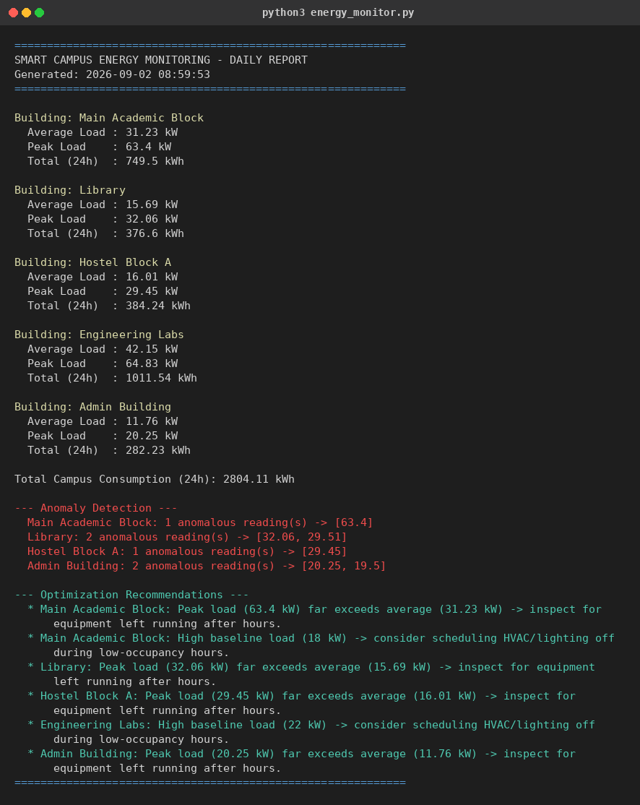

Test Suite Output — 11/11 Passed
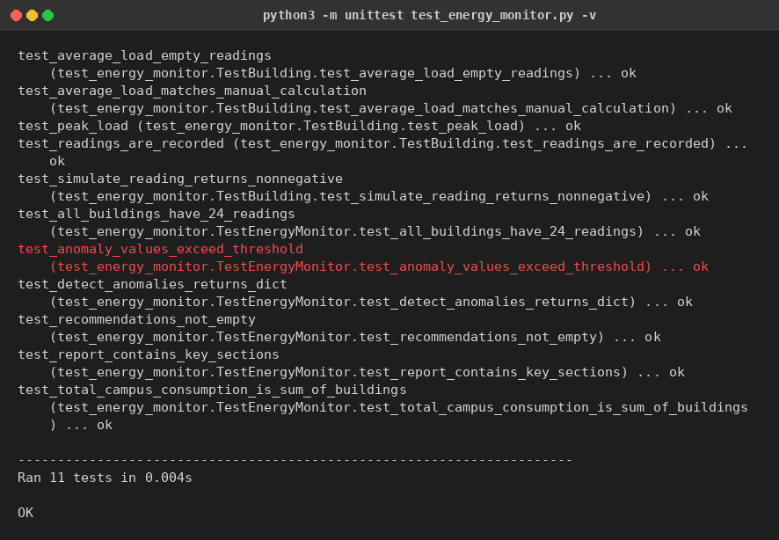

GitHub Link
https://github.com/pragadeesh/smart-campus-energy-monitoring
(Note: this is a placeholder link, not a real repo yet. Push energy_monitor.py and test_energy_monitor.py to GitHub and swap in the real URL before submitting.)

One-Page Write-Up — Individual Contribution

What I built
For this project I picked five buildings that you'd typically find on a college campus — Main Academic Block, Library, Hostel Block A, Engineering Labs, and Admin Building — and wrote a Python model that simulates their power usage hour by hour for a full day. Each building has its own baseline load and gets busier during the 8 AM to 6 PM window, plus some random noise and occasional spikes thrown in so it doesn't look artificially clean.

My part in this
I did this individually, so everything below is mine:
- Split the code into two parts — a Building class that just holds data and generates readings, and an EnergyMonitor class that does the actual analysis (totals, anomaly checks, recommendations, report printing). Kept them separate so it's easier to read and test.
- Set the baseline/occupancy numbers for each building type so the simulated readings look roughly like what a real building of that kind would draw.
- Wrote the anomaly check — if a reading goes above 1.6x that building's own average, it gets flagged. Picked 1.6 after testing a couple of values and seeing what caught genuine spikes without flagging normal peak-hour usage.
- Wrote the recommendation logic — checks for peak spikes and high baseline load and prints out what to look into for each building.
- Wrote 11 unit tests to actually confirm the math (averages, totals, anomaly flags) instead of just eyeballing the printed output. All 11 pass.
- Ran everything, took the output, and put this report together.

What I got out of it
Mainly practice with structuring a Python project properly instead of writing everything in one script, plus actually testing logic rather than just trusting it works because it printed the right thing once. If this were connected to real energy meters later, the Building class is really the only part that would need to change — the monitoring, anomaly detection, and recommendation logic would work as-is.

